A

Project Report

on

**DATABASE MANAGEMENT SYSTEM**

**CRYPTOCURRENCY TRADING PLATFORM**

DEVELOPED BY:

**RAJPUT KARAN – Department of IT, DD University**

**PATEL RONIL – Department of IT, DD University**

GUIDED BY:

**PROF. SUNIL K. VITHLANI**

**Department of Information Technology**

**Faculty of Technology**

**DDU University**



**Department of Information Technology**

**Faculty of Technology, Dharmsinh Desai University**

**College Road, Nadiad-387001**

**October - 2018**

## DHARMSINH DESAI UNIVERSITY

## NADIAD-387001, GUJARAT



## CERTIFICATE

### This is to certify that the project entitled CRYPTOCURRENCY TRADING PLATFORM

is a bonafied report of the work carried out by

1. Mr. RAJPUT KARAN N.

Student ID No: 16ITUBS007

1. Mr. PATEL RONIL G.

Student ID No: 16ITUBS149

of Department of Information Technology, semester V, under the guidance and supervision for the subject Database Management System. They were involved in Project training during academic year 2018-2019.

Prof. Sunil K. Vithlani(Project Guide)

Department of Information Technology,

Faculty of Technology,

Dharmsinh Desai University, Nadiad

Date:

Prof. Vipul Dabhi

Head, Department of Information Technology,

Faculty of Technology,

Dharmsinh Desai University, Nadiad

## Date:

**ACKNOWLEDGEMENT**

We would like to present the project report on “CRYPTOCURRENCY TRADING PLATFORM” and has given us wide opportunity to think, implement and interact with various aspects of management skills as well as the new emerging facilities and technology used in the architecture.

Every work that one completes successfully stands on the constant support, encouragement and good will of people around. I hereby avail this opportunity to express the gratitude to number of people who gave me their valuable time, immense support and all-time cooperation in the development of this project.

We would like to express our sincere gratitude to PROF SUNIL.K.VITHLANI who gave us an excellent opportunity to take up this project and to exceed our knowledge regarding this subject and provided us non-ending support for this project.

**Yours Sincerely**

RAJPUT KARAN

PATEL RONIL

**TABLE OF CONTENTS**

**I. Certificate II**

**II. Acknowledgement**

**1. SYSTEM OVERVIEW 4**

1.1 Current system 4

1.2 Objectives of the Proposed System 5

1.3 Advantages of the Proposed system (over current) 6

**2. E-R DIAGRAM 7**

2.1 Entities…………………………………………………………………………..8

2.2 Relationships……………………………………………………………………9

2.3 Mapping Constraints……………………………………………………………9

**3. DATA DICTIONARY 10**

**4. SCHEMA DIAGRAM 13**

**5. DATABASE IMPLEMENTION 14**

5.1 Create Schema 14

5.2 Insert Data values 27

5.3 Queries (Based on functions, group by, having, joins, sub query etc.) 40

5.4 PL/SQL Blocks (Procedures and Functions) 45

5.5 Views 53

5.6 Triggers 56

5.7 Cursors. 57

**6. FUTURE ENHANCEMENTS OF THE SYSTEM 59**

**7. BIBLIOGRAPHY 60**

1. **SYSTEM OVERVIEW**

**1.1 CURRENT SYSTEM**

**‘**CRYPTOCURRENCIES’ Which was declared the most searched topic in the near past by google – have gained immense popularity among the traders as well as professionals world wide.

The salient features that have fascinated the traders to adopt this include:-

* Decentralized payment system.
* Bypass the 3rd parties like banks.
* Works on hyperledger.
* Operates on blockchain technology.
* Smoothens & fastens the cross country payments.

To enable users to trade using the digital currencies, there exists a platform generally named ‘CRYPTOCURRENCY TRADING PLATFORM’. Trading platform provides the service to buy & sell the cryptocurrencies between users even among different countries, where there is availability of service.

Currently the trading platform provides the basic facility of buying and selling the cryptocurrencies. We can trace the price of any cryptocurrency. For all the implementation there are tables called ‘CRYPTOCURRENCY’, ‘PRICE_RECORDS’, ‘FOUNDER’, ‘CRYPTO_HAS_FOUNDER’, ‘TRADER_USER’, ‘ASSETS’, ‘USER_INFO’, ‘USER_HAS_EMAIL_ID’, ‘USER_HAS_CONTACT_NO’, ‘COUNTRY_HAS_CODE’, ‘BUYER_TRADER’, ‘SELLER_TRADER’, ‘TRADE_RECORD’.

**1.2 OBJECTIVES OF THE PROPOSED SYSTEM**

The basic objective of the project is to overcome the shortcomings that the current system inhibits. And also provide advanced features which will smoothens user experience.

**1.3 ADVANTAGES OF THE PROPOSED SYSTEM(**OVER CUREENT)

The flagship features include are:-

* Fetching the trading status of the user with whom one is going to trade.
* Also lists the founder of the cryptocurrencies which will let users increase the reliability.

1. **E-R DIAGRAM**

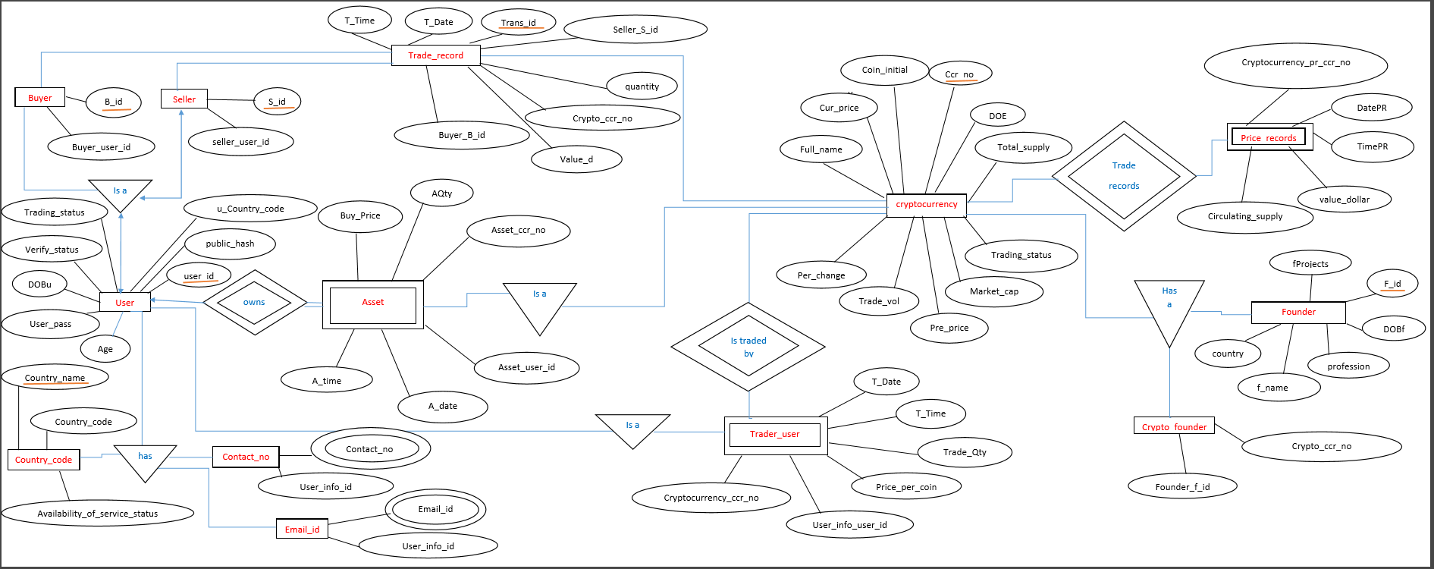

* 1. **ENTITIES**
  2. **RELATIONSHIPS**

**3. DATA DICTONARY**

1. **CRYPTOCURRENCY**

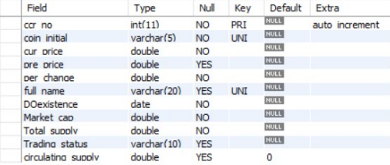

1. **PRICE_RECORDS**

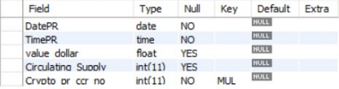

1. **FOUNDER**

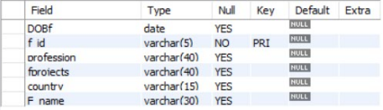

1. **CRYPTO_HAS_FOUNDER**

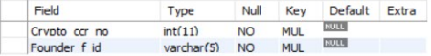

1. **TRADER_USER**

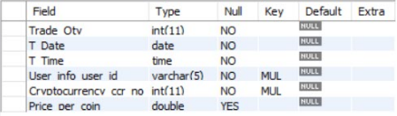

1. **ASSETS**

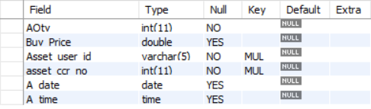

1. **USER_INFO**

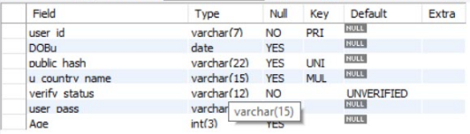

1. **USER_HAS_EMAIL_ID**

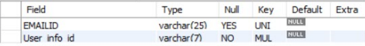

1. **USER_HAS_CONTACT_NO**

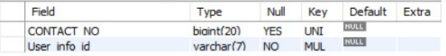

1. **COUNTRY_HAS_CODE**

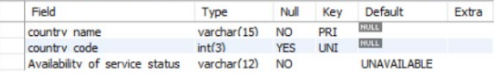

1. **BUYER_TRADER**

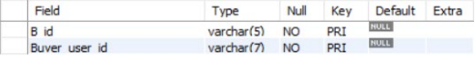

1. **SELLER_TRADER**

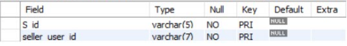

1. **TRADE_RECORD**

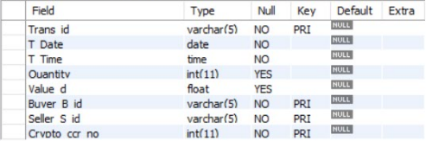

**4. SCHEMA DIAGRAM**

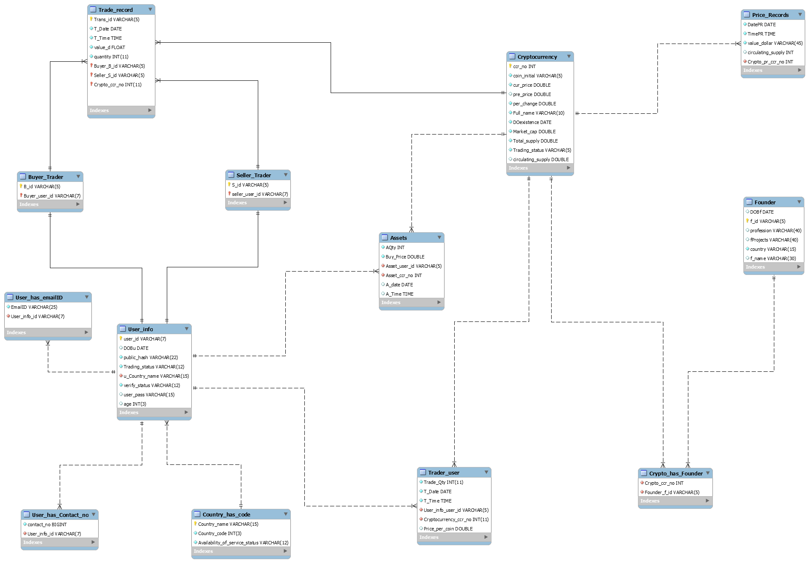

**5. DATABASE IMPLEMENTION**

5.1 SCHEMA

**CRYPTOCURRENCY**

CREATE TABLE IF NOT EXISTS `mydb`.`Cryptocurrency` (

`ccr_no` INT NOT NULL AUTO_INCREMENT,

`coin_initial` VARCHAR(5) NOT NULL,

`cur_price` DOUBLE NOT NULL,

`pre_price` DOUBLE NULL,

`per_change` DOUBLE NOT NULL,

`Full_name` VARCHAR(10) NOT NULL,

`DOexistence` DATE NOT NULL,

`Market_cap` DOUBLE NOT NULL,

`Total_supply` DOUBLE NOT NULL,

`Trading_status` VARCHAR(5) NOT NULL DEFAULT 'NO',

`circulating_supply` DOUBLE NULL DEFAULT 0.0,

PRIMARY KEY (`ccr_no`),

UNIQUE INDEX `ccr_no_UNIQUE` (`ccr_no` ASC),

UNIQUE INDEX `coin_initial_UNIQUE` (`coin_initial` ASC),

UNIQUE INDEX `Full_name_UNIQUE` (`Full_name` ASC))

ENGINE = InnoDB;

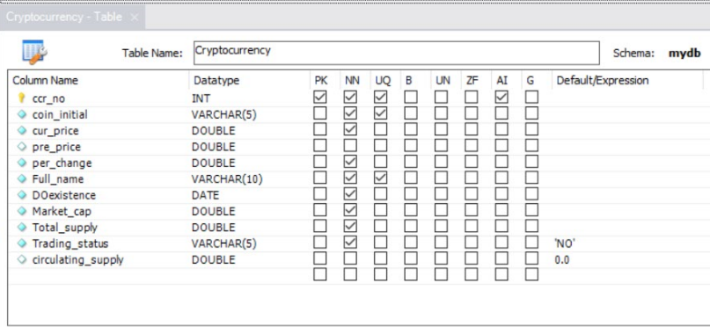

**PRICE_RECORDS**

CREATE TABLE IF NOT EXISTS `mydb`.`Price_Records` (

`DatePR` DATE NOT NULL,

`TimePR` TIME ,

`value_dollar` VARCHAR(45) NOT NULL,

`circulating_supply` INT NULL,

`Crypto_pr_ccr_no` INT NOT NULL,

INDEX `fk_Price_Records_Cryptocurrency1_idx` (`Crypto_pr_ccr_no` ASC),

CONSTRAINT `fk_Price_Records_Cryptocurrency1`

FOREIGN KEY (`Crypto_pr_ccr_no`)

REFERENCES `mydb`.`Cryptocurrency` (`ccr_no`)

ON DELETE NO ACTION

ON UPDATE NO ACTION)

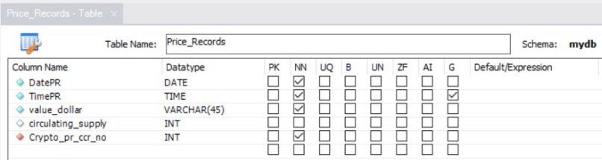

**FOUNDER**

CREATE TABLE IF NOT EXISTS `mydb`.`Founder` (

`DOBf` DATE NULL,

`f_id` VARCHAR(5) NOT NULL,

`profession` VARCHAR(40) NULL DEFAULT 'NONE',

`fProjects` VARCHAR(40) NULL DEFAULT 'NONE',

`country` VARCHAR(15) NOT NULL DEFAULT 'ANONYMOUS',

`f_name` VARCHAR(30) NULL,

PRIMARY KEY (`f_id`),

UNIQUE INDEX `f_id_UNIQUE` (`f_id` ASC))

ENGINE = InnoDB;

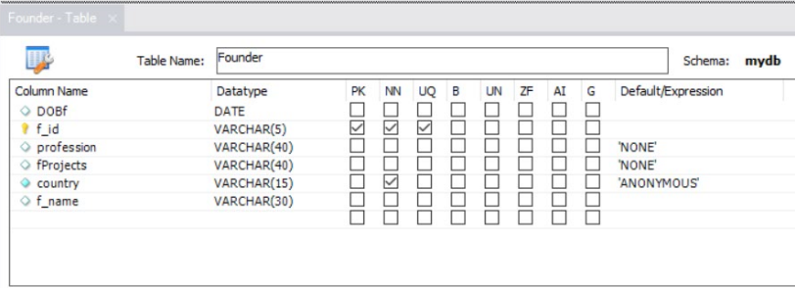

**CRYPYO_HAS_FOUNDER**

CREATE TABLE IF NOT EXISTS `mydb`.`Crypto_has_Founder` (

`Crypto_ccr_no` INT NOT NULL,

`Founder_f_id` VARCHAR(5) NOT NULL,

INDEX `fk_Cryptocurrency_has_Founder_Cryptocurrency_idx` (`Crypto_ccr_no` ASC),

INDEX `fk_Crypto_has_Founder_Founder1_idx` (`Founder_f_id` ASC),

CONSTRAINT `fk_Cryptocurrency_has_Founder_Cryptocurrency`

FOREIGN KEY (`Crypto_ccr_no`)

REFERENCES `mydb`.`Cryptocurrency` (`ccr_no`)

ON DELETE NO ACTION

ON UPDATE NO ACTION,

CONSTRAINT `fk_Crypto_has_Founder_Founder1`

FOREIGN KEY (`Founder_f_id`)

REFERENCES `mydb`.`Founder` (`f_id`)

ON DELETE NO ACTION

ON UPDATE NO ACTION)

ENGINE = InnoDB;

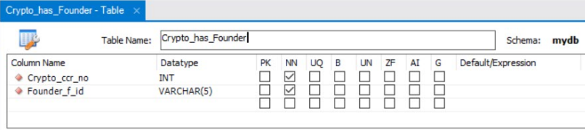

**TRADER_USER**

CREATE TABLE IF NOT EXISTS `mydb`.`Trader_user` (

`Trade_Qty` INT(11) NOT NULL,

`T_Date` DATE NOT NULL,

`T_Time` TIME NOT NULL,

`User_info_user_id` VARCHAR(5) NOT NULL,

`Cryptocurrency_ccr_no` INT(11) NOT NULL,

`Price_per_coin` DOUBLE NULL,

INDEX `fk_Trader_user_User_info1_idx` (`User_info_user_id` ASC),

INDEX `fk_Trader_user_Cryptocurrency1_idx` (`Cryptocurrency_ccr_no` ASC),

CONSTRAINT `fk_Trader_user_User_info1`

FOREIGN KEY (`User_info_user_id`)

REFERENCES `mydb`.`User_info` (`user_id`)

ON DELETE NO ACTION

ON UPDATE NO ACTION,

CONSTRAINT `fk_Trader_user_Cryptocurrency1`

FOREIGN KEY (`Cryptocurrency_ccr_no`)

REFERENCES `mydb`.`Cryptocurrency` (`ccr_no`)

ON DELETE NO ACTION

ON UPDATE NO ACTION)

ENGINE = InnoDB;

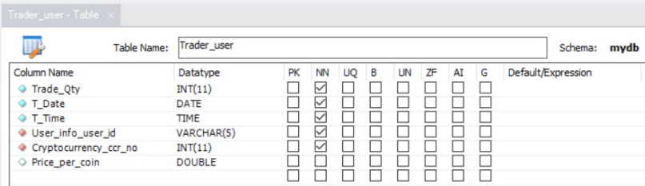

**ASSETS**

CREATE TABLE IF NOT EXISTS `mydb`.`Assets` (

`AQty` INT NOT NULL,

`Buy_Price` DOUBLE NOT NULL,

`Asset_user_id` VARCHAR(5) NOT NULL,

`Asset_ccr_no` INT NOT NULL,

`A_date` DATE NULL,

`A_Time` TIME NULL,

INDEX `fk_Assets_Cryptocurrency1_idx` (`Asset_ccr_no` ASC),

CONSTRAINT `fk_Assets_User_info1`

FOREIGN KEY (`Asset_user_id`)

REFERENCES `mydb`.`User_info` (`user_id`)

ON DELETE NO ACTION

ON UPDATE NO ACTION,

CONSTRAINT `fk_Assets_Cryptocurrency1`

FOREIGN KEY (`Asset_ccr_no`)

REFERENCES `mydb`.`Cryptocurrency` (`ccr_no`)

ON DELETE NO ACTION

ON UPDATE NO ACTION)

ENGINE = InnoDB;

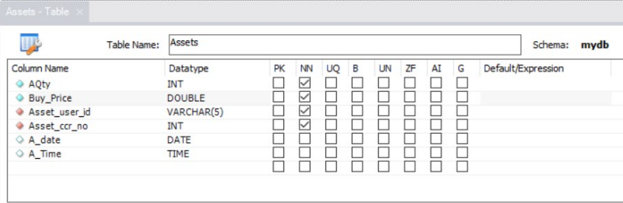

**USER_INFO**

CREATE TABLE IF NOT EXISTS `mydb`.`User_info` (

`user_id` VARCHAR(7) NOT NULL,

`DOBu` DATE NULL,

`public_hash` VARCHAR(22) NOT NULL,

`u_Country_name` VARCHAR(15) NOT NULL,

`verify_status` VARCHAR(12) NOT NULL DEFAULT 'UNVERIFIED',

`user_pass` VARCHAR(15) NULL,

`age` INT(3) NULL,

PRIMARY KEY (`user_id`),

INDEX `fk_User_info_Country_has_code1_idx` (`u_Country_name` ASC),

UNIQUE INDEX `user_id_UNIQUE` (`user_id` ASC),

UNIQUE INDEX `public_hash_UNIQUE` (`public_hash` ASC),

CONSTRAINT `fk_User_info_Country_has_code1`

FOREIGN KEY (`u_Country_name`)

REFERENCES `mydb`.`Country_has_code` (`Country_name`)

ON DELETE NO ACTION

ON UPDATE NO ACTION)

ENGINE = InnoDB;

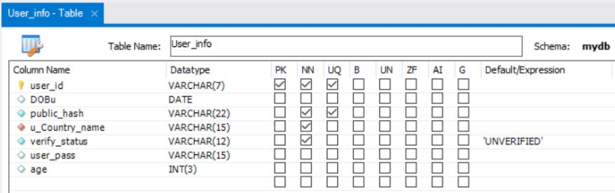

**USER_HAS_EMAIL_ID**

CREATE TABLE IF NOT EXISTS `mydb`.`User_has_emailID` (

`EmailID` VARCHAR(25) NOT NULL,

`User_info_id` VARCHAR(7) NOT NULL,

INDEX `fk_User_has_emailID_User_info1_idx` (`User_info_id` ASC),

UNIQUE INDEX `EmailID_UNIQUE` (`EmailID` ASC),

CONSTRAINT `fk_User_has_emailID_User_info1`

FOREIGN KEY (`User_info_id`)

REFERENCES `mydb`.`User_info` (`user_id`)

ON DELETE NO ACTION

ON UPDATE NO ACTION)

ENGINE = InnoDB;

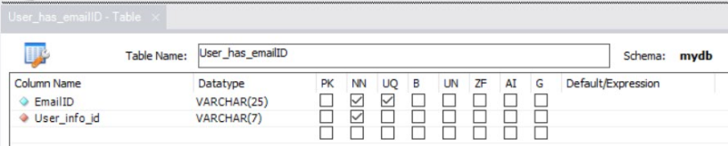

**USER_HAS_CONTACT_NO**

CREATE TABLE IF NOT EXISTS `mydb`.`User_has_Contact_no` (

`contact_no` BIGINT NOT NULL,

`User_info_id` VARCHAR(7) NOT NULL,

INDEX `fk_User_has_Contact_no_User_info1_idx` (`User_info_id` ASC),

UNIQUE INDEX `User_contact_no_UNIQUE` (`contact_no` ASC),

CONSTRAINT `fk_User_has_Contact_no_User_info1`

FOREIGN KEY (`User_info_id`)

REFERENCES `mydb`.`User_info` (`user_id`)

ON DELETE NO ACTION

ON UPDATE NO ACTION)

ENGINE = InnoDB

COMMENT = ' ';

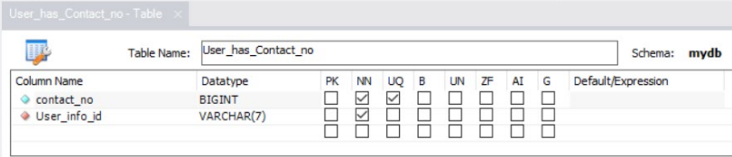

**COUNTRY_HAS_CODE**

CREATE TABLE IF NOT EXISTS `mydb`.`Country_has_code` (

`Country_name` VARCHAR(15) NOT NULL,

`Country_code` INT(3) NOT NULL,

`Availability_of_service_status` VARCHAR(12) NOT NULL DEFAULT 'UNAVAILABLE',

PRIMARY KEY (`Country_name`),

UNIQUE INDEX `Country_code_UNIQUE` (`Country_code` ASC),

UNIQUE INDEX `Country_name_UNIQUE` (`Country_name` ASC))

ENGINE = InnoDB;

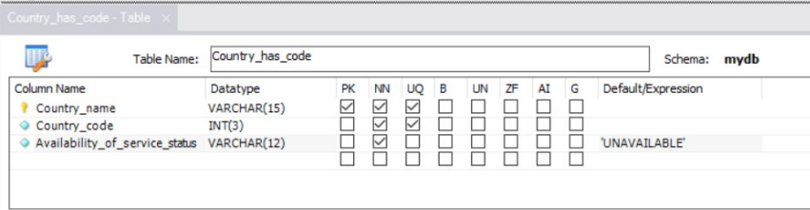

**BUYER_TRADER**

CREATE TABLE IF NOT EXISTS `mydb`.`Buyer_Trader` (

`B_id` VARCHAR(5) NOT NULL,

`Buyer_user_id` VARCHAR(7) NOT NULL,

PRIMARY KEY (`B_id`, `Buyer_user_id`),

INDEX `fk_Buyer_Trader_User_info1_idx` (`Buyer_user_id` ASC),

UNIQUE INDEX `B_id_UNIQUE` (`B_id` ASC),

UNIQUE INDEX `Buyer_user_id_UNIQUE` (`Buyer_user_id` ASC),

CONSTRAINT `fk_Buyer_Trader_User_info1`

FOREIGN KEY (`Buyer_user_id`)

REFERENCES `mydb`.`User_info` (`user_id`)

ON DELETE NO ACTION

ON UPDATE NO ACTION)

ENGINE = InnoDB;

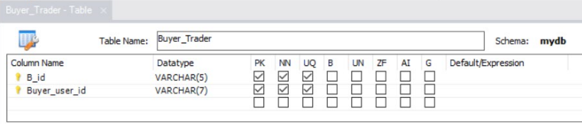

**SELLER_TRADER**

CREATE TABLE IF NOT EXISTS `mydb`.`Seller_Trader` (

`S_id` VARCHAR(5) NOT NULL,

`seller_user_id` VARCHAR(7) NOT NULL,

PRIMARY KEY (`S_id`, `seller_user_id`),

INDEX `fk_Seller_Trader_User_info1_idx` (`seller_user_id` ASC),

UNIQUE INDEX `S_id_UNIQUE` (`S_id` ASC),

UNIQUE INDEX `seller_user_id_UNIQUE` (`seller_user_id` ASC),

CONSTRAINT `fk_Seller_Trader_User_info1`

FOREIGN KEY (`seller_user_id`)

REFERENCES `mydb`.`User_info` (`user_id`)

ON DELETE NO ACTION

ON UPDATE NO ACTION)

ENGINE = InnoDB;

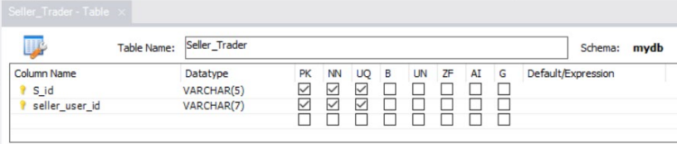

**TRADE_RECORDS**

CREATE TABLE IF NOT EXISTS `mydb`.`Trade_record` (

`Trans_id` VARCHAR(5) NOT NULL,

`T_Date` DATE NOT NULL,

`T_Time` TIME NOT NULL,

`value_d` FLOAT NOT NULL,

`quantity` INT(11) NOT NULL,

`Buyer_B_id` VARCHAR(5) NOT NULL,

`Seller_S_id` VARCHAR(5) NOT NULL,

`Crypto_ccr_no` INT(11) NOT NULL,

PRIMARY KEY (`Trans_id`, `Seller_S_id`, `Crypto_ccr_no`, `Buyer_B_id`),

INDEX `fk_Trade_record_Buyer_Trader1_idx` (`Buyer_B_id` ASC),

INDEX `fk_Trade_record_Seller_Trader1_idx` (`Seller_S_id` ASC),

INDEX `fk_Trade_record_Cryptocurrency1_idx` (`Crypto_ccr_no` ASC),

UNIQUE INDEX `Trans_id_UNIQUE` (`Trans_id` ASC),

CONSTRAINT `fk_Trade_record_Buyer_Trader1`

FOREIGN KEY (`Buyer_B_id`)

REFERENCES `mydb`.`Buyer_Trader` (`B_id`)

ON DELETE NO ACTION

ON UPDATE NO ACTION,

CONSTRAINT `fk_Trade_record_Seller_Trader1`

FOREIGN KEY (`Seller_S_id`)

REFERENCES `mydb`.`Seller_Trader` (`S_id`)

ON DELETE NO ACTION

ON UPDATE NO ACTION,

CONSTRAINT `fk_Trade_record_Cryptocurrency1`

FOREIGN KEY (`Crypto_ccr_no`)

REFERENCES `mydb`.`Cryptocurrency` (`ccr_no`)

ON DELETE NO ACTION

ON UPDATE NO ACTION)

ENGINE = InnoDB;

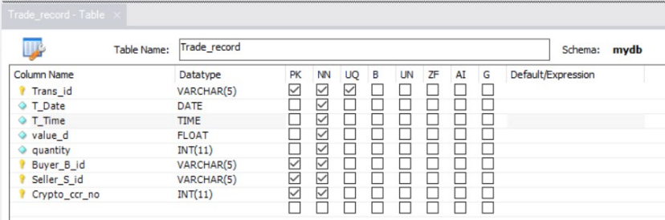

**5.2 INSERT DATA VALUES**

1. **CRYPTOCURRENCY**

INSERT INTO `mydb`.`cryptocurrency` (`ccr_no`, `coin_initial`, `cur_price`, `pre_price`, `per_change`, `Trade_vol`, `Full_name`, `DOexistence`, `Market_cap`, `Trading_status`, `circulating_supply`) VALUES ('1001', 'BTC', '6556.56', '0', '0', 'Bitcoin', '2010-03-24', '0', '2100000', '', '178000');

INSERT INTO `mydb`.`cryptocurrency` (`ccr_no`, `coin_initial`, `cur_price`, `pre_price`, `per_change`, `Full_name`, `DOexistence`, `Market_cap`, `Total_supply`, `Trading_status`, `circulating_supply`) VALUES ('1002', 'ETH', '365.89', '0', '0', 'Ethereum', '2011-06-04', '0', '1300000', '', '109000');

INSERT INTO `mydb`.`cryptocurrency` (`ccr_no`, `coin_initial`, `cur_price`, `pre_price`, `per_change`, `Full_name`, `DOexistence`, `Market_cap`, `Total_supply`, `Trading_status`, `circulating_supply`) VALUES ('1003', 'XRP', '15.96', '0', '0', 'Ripple', '2016-09-21', '0', '10000000', '', '390000');

INSERT INTO `mydb`.`cryptocurrency` (`ccr_no`, `coin_initial`, `cur_price`, `pre_price`, `per_change`, `Full_name`, `DOexistence`, `Market_cap`, `Total_supply`, `Trading_status`, `circulating_supply`) VALUES ('1004', 'BCH', '4866.65', '0', '0', 'Bitcoin Cash', '2012-04-13', '0', '5680000', '', '892300');

INSERT INTO `mydb`.`cryptocurrency` (`ccr_no`, `coin_initial`, `cur_price`, `pre_price`, `per_change`, `Full_name`, `DOexistence`, `Market_cap`, `Total_supply`, `Trading_status`, `circulating_supply`) VALUES ('1005', 'EOS', '896.56', '0', '0', 'EOS', '2012-07-27', '0', '150000', '', '65897');

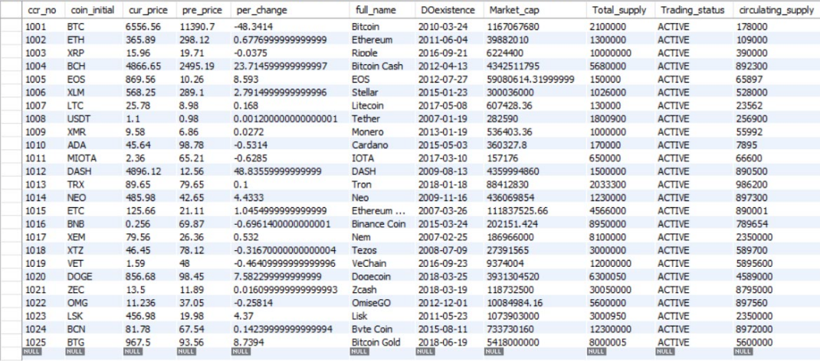

1. **PRICE_RECORDS**

INSERT INTO `mydb`.`price_records` (`DatePR`, `TimePR`, `value_dollar`, `Market_Cap`, `Crypto_pr_ccr_no`) VALUES ('2010-03-24', '13:00:00', '188.65', '0', '1001');

INSERT INTO `mydb`.`price_records` (`DatePR`, `TimePR`, `value_dollar`, `Market_Cap`, `Crypto_pr_ccr_no`) VALUES ('2011-06-04', '21:48:06', '26.89', '0', '1002');

INSERT INTO `mydb`.`price_records` (`DatePR`, `TimePR`, `value_dollar`, `Market_Cap`, `Crypto_pr_ccr_no`) VALUES ('2016-09-21', '01:01:38', '65', '0', '1003');

INSERT INTO `mydb`.`price_records` (`DatePR`, `TimePR`, `value_dollar`, `Market_Cap`, `Crypto_pr_ccr_no`) VALUES ('2012-04-13', '12:46:51', '89.68', '0', '1004');

INSERT INTO `mydb`.`price_records` (`DatePR`, `TimePR`, `value_dollar`, `Market_Cap`, `Crypto_pr_ccr_no`) VALUES ('2012-07-27', '12:10:00', '10.26', '0', '1005');

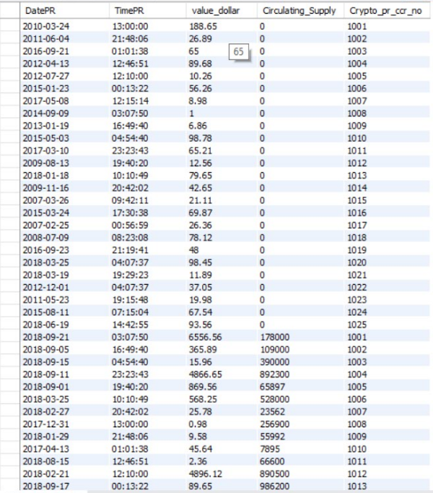

1. **FOUNDER**

INSERT INTO `mydb`.`founder` (`DOBf`, `f_id`, `profession`, `fprojects`, `country`, `F_name`) VALUES ('1962-09-18', 'F1001', 'Professor', 'Cross Border Payment', 'Japan', 'Satoshi Nakamoto');

INSERT INTO `mydb`.`founder` (`DOBf`, `f_id`, `profession`, `fprojects`, `country`, `F_name`) VALUES ('1988-04-26', 'F1002', 'Tech Innovator', 'Fuel Cryptocurrency', 'USA', 'Vitalik Buterin');

INSERT INTO `mydb`.`founder` (`DOBf`, `f_id`, `profession`, `fprojects`, `country`, `F_name`) VALUES ('1986-04-12', 'F1003', 'Data Scientist', 'Game Industry Advertisement', 'Germany', 'Micheal Fronsi');

INSERT INTO `mydb`.`founder` (`DOBf`, `f_id`, `profession`, `fprojects`, `country`, `F_name`) VALUES ('1981-07-06', 'F1004', 'Professor', 'Banking Blockchain', 'USA', 'Joerge Wills');

INSERT INTO `mydb`.`founder` (`DOBf`, `f_id`, `profession`, `fprojects`, `country`, `F_name`) VALUES ('1990-01-01', 'F1005', 'Scientist', 'Scientific Research Publication', 'Australia', 'Naini Stalin');

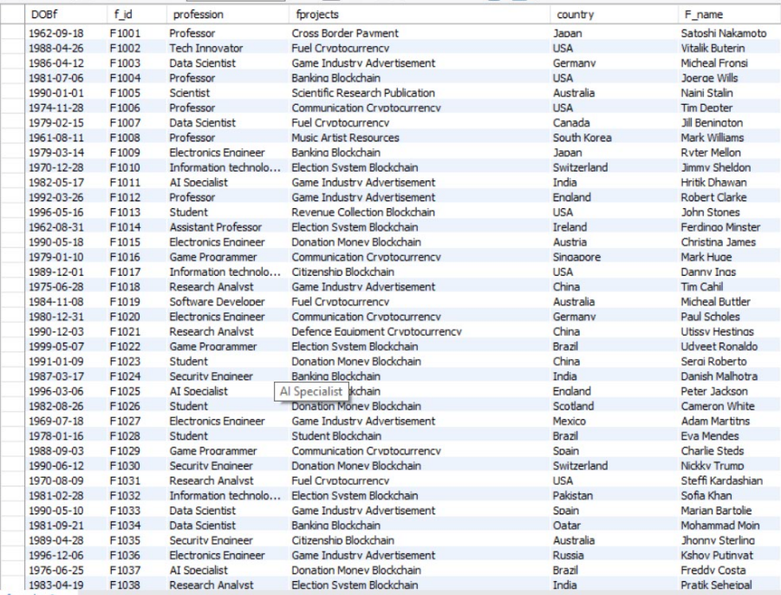

1. **CRYPTO_HAS_FOUNDER**

INSERT INTO `mydb`.`crypto_has_founder` (`Crypto_ccr_no`, `Founder_f_id`) VALUES ('1001', 'F1001');

INSERT INTO `mydb`.`crypto_has_founder` (`Crypto_ccr_no`, `Founder_f_id`) VALUES ('1002', 'F1002');

INSERT INTO `mydb`.`crypto_has_founder` (`Crypto_ccr_no`, `Founder_f_id`) VALUES ('1003', 'F1003');

INSERT INTO `mydb`.`crypto_has_founder` (`Crypto_ccr_no`, `Founder_f_id`) VALUES ('1003', 'F1010');

INSERT INTO `mydb`.`crypto_has_founder` (`Crypto_ccr_no`, `Founder_f_id`) VALUES ('1003', 'F1021');

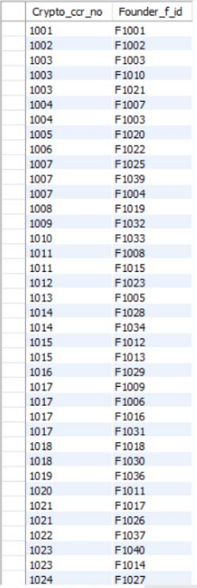

1. **TRADER_USER**

INSERT INTO `mydb`.`trader_user` (`Trade_Qty`, `T_Date`, `T_Time`, `User_info_user_id`, `Cryptocurrency_ccr_no`, `Price_per_coin`) VALUES ('10', '2016-02-21', '13:00:00', 'U1015', '1001', '7956');

INSERT INTO `mydb`.`trader_user` (`Trade_Qty`, `T_Date`, `T_Time`, `User_info_user_id`, `Cryptocurrency_ccr_no`, `Price_per_coin`) VALUES ('3', '2017-12-30', '21:48:06', 'U1008', '1007', '11.23');

INSERT INTO `mydb`.`trader_user` (`Trade_Qty`, `T_Date`, `T_Time`, `User_info_user_id`, `Cryptocurrency_ccr_no`, `Price_per_coin`) VALUES ('45', '2018-04-21', '01:01:38', 'U1022', '1013', '81.56');

INSERT INTO `mydb`.`trader_user` (`Trade_Qty`, `T_Date`, `T_Time`, `User_info_user_id`, `Cryptocurrency_ccr_no`, `Price_per_coin`) VALUES ('1', '2018-06-03', '12:46:51', 'U1011', '1013', '80');

INSERT INTO `mydb`.`trader_user` (`Trade_Qty`, `T_Date`, `T_Time`, `User_info_user_id`, `Cryptocurrency_ccr_no`, `Price_per_coin`) VALUES ('22', '2018-09-20', '12:10:00', 'U1001', '1025', '90.56');

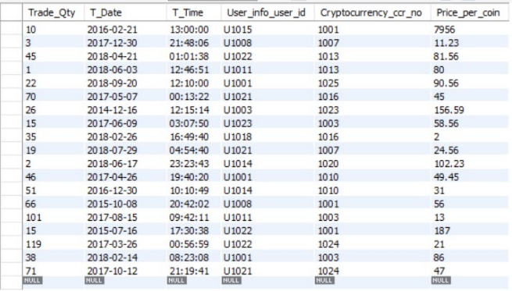

1. **ASSETS**

INSERT INTO `mydb`.`assets` (`AQty`, `Buy_Price`, `Asset_user_id`, `asset_ccr_no`, `A_date`, `A_time`) VALUES ('114', '225.65', 'U1001', '1001', '2010-04-20', '23:15:06');

INSERT INTO `mydb`.`assets` (`AQty`, `Buy_Price`, `Asset_user_id`, `asset_ccr_no`, `A_date`, `A_time`) VALUES ('71', '79.81', 'U1023', '1003', '2016-11-05', '11:50:51');

INSERT INTO `mydb`.`assets` (`AQty`, `Buy_Price`, `Asset_user_id`, `asset_ccr_no`, `A_date`, `A_time`) VALUES ('36', '31.78', 'U1021', '1007', '2018-06-10', '21:01:19');

INSERT INTO `mydb`.`assets` (`AQty`, `Buy_Price`, `Asset_user_id`, `asset_ccr_no`, `A_date`, `A_time`) VALUES ('93', '159.65', 'U1003', '1023', '2012-04-24', '07:34:20');

INSERT INTO `mydb`.`assets` (`AQty`, `Buy_Price`, `Asset_user_id`, `asset_ccr_no`, `A_date`, `A_time`) VALUES ('67', '17.23', 'U1001', '1003', '2018-01-14', '19:14:54');

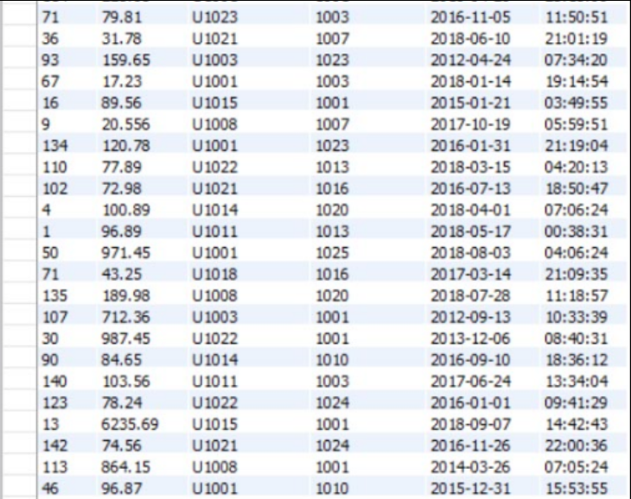

1. **USER_INFO**

INSERT INTO `mydb`.`user_info` (`user_id`, `DOBu`, `public_hash`, `net_worth_d`, `Trading_status`, `u_Country_name`, `verify_status`, `user_pass`) VALUES ('U1001', '1980-02-14', '4eba3b843dbab95f6d9j', '', '', 'INDIA', 'VERIFIED', 'KThxz2');

INSERT INTO `mydb`.`user_info` (`user_id`, `DOBu`, `public_hash`, `net_worth_d`, `Trading_status`, `u_Country_name`, `verify_status`, `user_pass`) VALUES ('U1002', '1996-11-27', 'ac26792712f60b2a2f16', '', '', 'USA', 'UNVERIFIED', 'HHrnDtT');

INSERT INTO `mydb`.`user_info` (`user_id`, `DOBu`, `public_hash`, `net_worth_d`, `Trading_status`, `u_Country_name`, `verify_status`, `user_pass`) VALUES ('U1003', '1969-12-17', 'db66f67734852c60373i', '', '', 'JAPAN', 'UNVERIFIED', 'RcBldRQ6Tb4a');

INSERT INTO `mydb`.`user_info` (`user_id`, `DOBu`, `public_hash`, `net_worth_d`, `Trading_status`, `u_Country_name`, `verify_status`, `user_pass`) VALUES ('U1004', '1980-08-09', 'b94ee02f5c5530db912t', '', '', 'CANADA', 'VERIFIED', 'mnTSwQolix');

INSERT INTO `mydb`.`user_info` (`user_id`, `DOBu`, `public_hash`, `net_worth_d`, `Trading_status`, `u_Country_name`, `verify_status`, `user_pass`) VALUES ('U1005', '1978-08-14', 'f9076ffee6fed72075560', '', '', 'NEW ZEALAND', 'UNVERIFIED', 'AiQotCiidu');

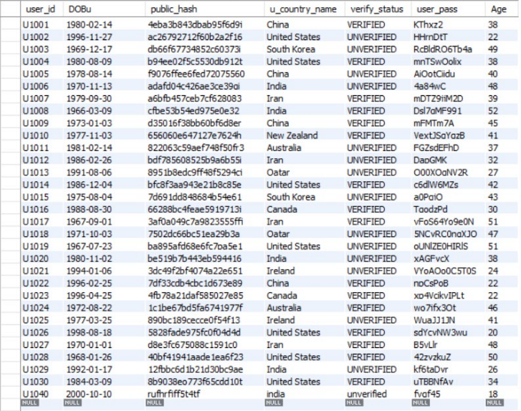

1. **USER_HAS_EMAIL_ID**

INSERT INTO `mydb`.`user_has_emailid` (`EMAILID`, `User_info_id`) VALUES ('acashen0@prlog.org', 'U1001');

INSERT INTO `mydb`.`user_has_emailid` (`EMAILID`, `User_info_id`) VALUES ('rburwell1@phoca.cz', 'U1002');

INSERT INTO `mydb`.`user_has_emailid` (`EMAILID`, `User_info_id`) VALUES ('jludman2@goo.ne.jp', 'U1003');

INSERT INTO `mydb`.`user_has_emailid` (`EMAILID`, `User_info_id`) VALUES ('tdalgety3@joomla.org', 'U1004');

INSERT INTO `mydb`.`user_has_emailid` (`EMAILID`, `User_info_id`) VALUES ('gscudamore4@i2i.jp', 'U1005');

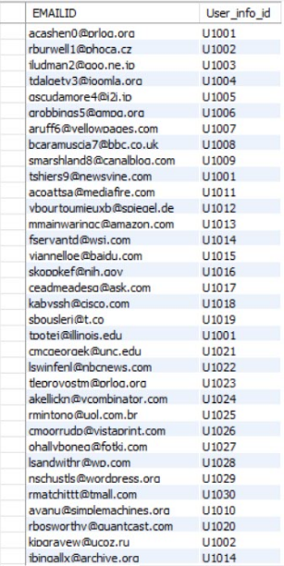

1. **USER_HAS_CONTACT_NO**

INSERT INTO `mydb`.`user_has_contact_no` (`contact_no`, `User_info_id`) VALUES ('2262165883', 'U1001');

INSERT INTO `mydb`.`user_has_contact_no` (`contact_no`, `User_info_id`) VALUES ('6345638417', 'U1002');

INSERT INTO `mydb`.`user_has_contact_no` (`contact_no`, `User_info_id`) VALUES ('6598571375', 'U1003');

INSERT INTO `mydb`.`user_has_contact_no` (`contact_no`, `User_info_id`) VALUES ('4356599810', 'U1004');

INSERT INTO `mydb`.`user_has_contact_no` (`contact_no`, `User_info_id`) VALUES ('6986965523', 'U1005');

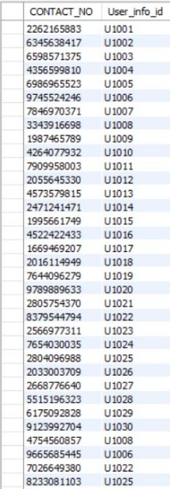

1. **COUNTRY_HAS_CODE**

INSERT INTO `mydb`.`country_has_code` (`country_name`, `country_code`,`availability_of_service_status`) VALUES ('australia', '31',`available`);

INSERT INTO `mydb`.`country_has_code` (`country_name`, `country_code`,`availability_of_service_status`) VALUES ('austria', '74',`unavailable`);

INSERT INTO `mydb`.`country_has_code` (`country_name`, `country_code`,`availability_of_service_status`) VALUES ('bangladesh', '94',`unavailable`);

INSERT INTO `mydb`.`country_has_code` (`country_name`, `country_code`,`availability_of_service_status`) VALUES ('canada', '96',`available`);

INSERT INTO `mydb`.`country_has_code` (`country_name`, `country_code`,`availability_of_service_status`) VALUES ('china', '56',`available`);

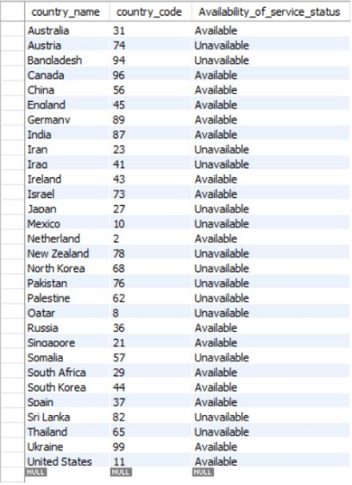

1. **BUYER_TRADER**

INSERT INTO `mydb`.`buyer_trader` (`B_id`, `Buyer_user_id`) VALUES ('B1001', 'U1001');

INSERT INTO `mydb`.`buyer_trader` (`B_id`, `Buyer_user_id`) VALUES ('B1002', 'U1002');

INSERT INTO `mydb`.`buyer_trader` (`B_id`, `Buyer_user_id`) VALUES ('B1003', 'U1003');

INSERT INTO `mydb`.`buyer_trader` (`B_id`, `Buyer_user_id`) VALUES ('B1004', 'U1004');

INSERT INTO `mydb`.`buyer_trader` (`B_id`, `Buyer_user_id`) VALUES ('B1005', 'U1005');

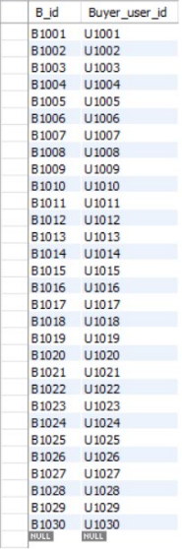

1. **SELLER_TRADER**

INSERT INTO `mydb`.`seller_trader` (`S_id`, `seller_user_id`) VALUES ('S1001', 'U1001');

INSERT INTO `mydb`.`seller_trader` (`S_id`, `seller_user_id`) VALUES ('S1002', 'U1002');

INSERT INTO `mydb`.`seller_trader` (`S_id`, `seller_user_id`) VALUES ('S1003', 'U1003');

INSERT INTO `mydb`.`seller_trader` (`S_id`, `seller_user_id`) VALUES ('S1004', 'U1004');

INSERT INTO `mydb`.`seller_trader` (`S_id`, `seller_user_id`) VALUES ('S1005', 'U1005');

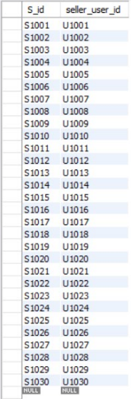

1. **TRADE_RECORDS**

INSERT INTO `mydb`.`trade_record` (`Trans_id`, `T_Date`, `T_Time`, `T_total_value`, `T_Qty`, `Buyer_B_id`, `Seller_S_id`, `Crypto_ccr_no`) VALUES ('T1001', '2010-04-20', '23:15:06', '114', '225.65', 'B1001', 'S1010', '1001');

INSERT INTO `mydb`.`trade_record` (`Trans_id`, `T_Date`, `T_Time`, `T_total_value`, `T_Qty`, `Buyer_B_id`, `Seller_S_id`, `Crypto_ccr_no`) VALUES ('T1002', '2016-11-05', '11:50:51', '71', '79.81', 'B1023', 'S1021', '1003');

INSERT INTO `mydb`.`trade_record` (`Trans_id`, `T_Date`, `T_Time`, `T_total_value`, `T_Qty`, `Buyer_B_id`, `Seller_S_id`, `Crypto_ccr_no`) VALUES ('T1003', '2018-06-10', '21:01:19', '36', '31.78', 'B1021', 'S1004', '1007');

INSERT INTO `mydb`.`trade_record` (`Trans_id`, `T_Date`, `T_Time`, `T_total_value`, `T_Qty`, `Buyer_B_id`, `Seller_S_id`, `Crypto_ccr_no`) VALUES ('T1004', '2012-04-24', '07:34:20', '93', '159.65', 'B1003', 'S1023', '1023');

INSERT INTO `mydb`.`trade_record` (`Trans_id`, `T_Date`, `T_Time`, `T_total_value`, `T_Qty`, `Buyer_B_id`, `Seller_S_id`, `Crypto_ccr_no`) VALUES ('T1005', '2018-01-14', '19:14:54', '67', '17.23', 'B1001', 'S1011', '1003');

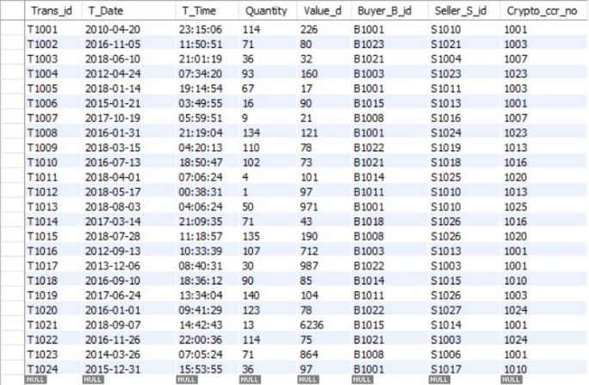

**5.3 Queries (Based on functions, group by, having, joins, sub query etc.)**

1. **Find the fluctuation(in terms of number) of all the cryptocurrency in existence. Also display the cryptocurrency number.**

**-**

* SELECT COUNT(*)*FLUCTUATION”,CRYPTO_PR_CCR_NO

FROM PRICE_RECORDS GROUP BY CRYPTO_PR_CCR_NO;

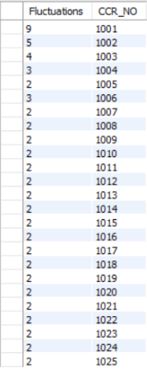

1. **Display users along with their buyer_id & transaction amount who have traded the cryptocurrency ‘10001’.**

* SELECT BT.B_ID,BT.BUYER_USER_ID,(TR.QUANTITY*TR.VALUE_D) AS TRANSACTION_AMT FROM TRADE_RECORD TR INNER JOIN BUYER_TRADER BT ON TR.BUYER_B_ID=BT.B_ID WHERE TR.CRYPTO_CCR_NO=’1001’;

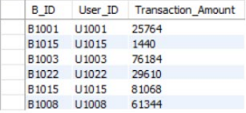

1. **Display the profit % of all the user who are holding the cryptocurrency with ccr_no=’1001’.**

* SELECT A.ASSET_USER_ID,SUM(((C.CUR_PRICE-A.BUY_PRICE)/A.BUY_PRICE)*100) AS PROFIT FROM ASSET A INNER JOIN CRYPTOCURRENCY C ON C.CCR_NO=A.ASSET_CCR_NO WHERE C.CCR_NO='1001' AND

(C.CUR_PRICE-A.BUY_PRICE)>0;

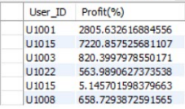

1. **Find the users in descending order with their networth on the basis of buy_price of all the assets they own.**

* SELECT ASSET_USER_ID,SUM(AQTY*BUY_PRICE) AS TOTAL_ASSET FROM ASSETS GROUP BY ASSET_USER_ID ORDER BY TOTAL_ASSET DESC;

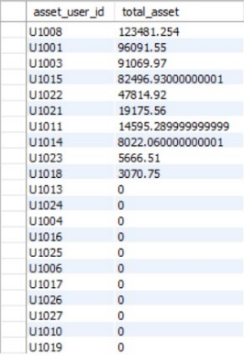

1. **Display the maximum quantity of cryptocurrency from each single user which are put on sale.**

* SELECT

USER_INFO_USER_ID,CRYPTOCURRENCY_CCR_NO,MAX(TRADE_QTY) FROM TRADER_USER GROUP BY CRYPTOCURRENCY_CCR_NO;

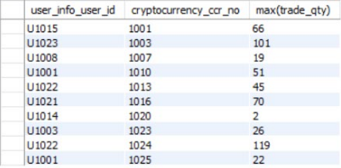

1. **Display users with their country name where the trading service is offered by the trading platform.**

* SELECT UI.USER_ID,UI.U_COUNTRY_NAME,CC.AVAILABILITY_OF_SERVICE_STATUS FROM USER_INFO UI INNER JOIN COUNTRY_HAS_CODE CC ON CC.COUNTRY_NAME=UI.U_COUNTRY_NAME WHERE CC.AVAILABILITY_OF_SERVICE_STATUS LIKE 'A%';

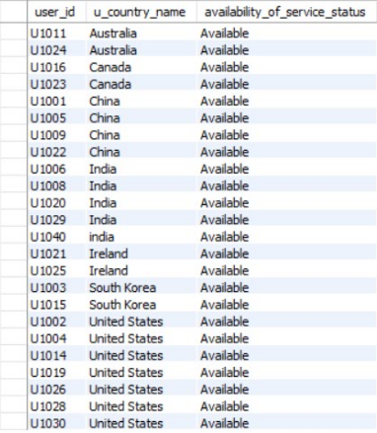

1. **Find the founder from China, USA and India along with their profession, future working project & cryptocurrency they founded.**

* SELECT * FROM FOUNDER F LEFT OUTER JOIN CRYPTO_HAS_FOUNDER CF ON F.F_ID=CF.FOUNDER_F_ID WHERE F.COUNTRY IN ('CHINA','USA','INDIA');

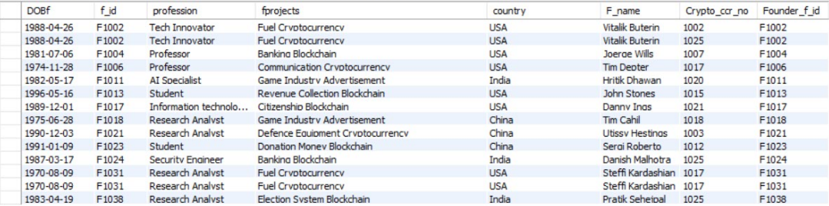

1. **Find the users who have cryptocurrencies in quantity greater than 100.**

* SELECT * FROM ASSETS WHERE AQTY=ANY(SELECT AQTY FROM ASSETS WHERE AQTY>100);

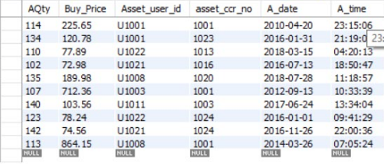

1. **Display cryptocurrencies with their Date of Existence, launch price and current price.**

* SELECT PR.VALUE_DOLLAR,PR.CRYPTO_PR_CCR_NO,C.CUR_PRICE FROM PRICE_RECORDS PR INNER JOIN CRYPTOCURRENCY C ON PR.CRYPTO_PR_CCR_NO=C.CCR_NO WHERE PR.DATEPR=C.DOEXISTENCE;

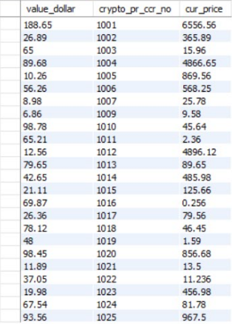

1. **Display all the transaction records for all the cryptocurrencies for the current year 2018.**

* SELECT * FROM TRADE_RECORD WHERE EXTRACT(YEAR FROM T_DATE)=2018;

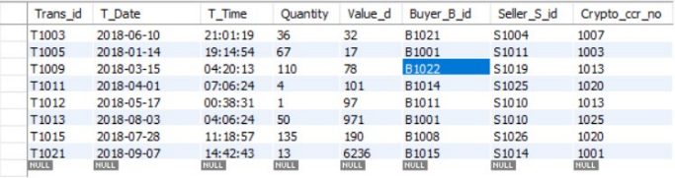

* 1. **PL/SQL Blocks (Procedures and Functions)**

**1.PROCEDURES**

1. **PROCEDURE FOR EXCEPTION HANDLING OF INSUFFICIENT QUANTITY.**

CREATE DEFINER=`root`@`localhost` PROCEDURE `add_trader_user`(in curr_qty int,in uiu varchar(5),in ccrno int,in price double)

BEGIN

declare amt double;

declare qty int;

select aqty into qty from assets where asset_user_id =uiu and asset_ccr_no=ccr;

if (curr_qty>qty) then

signal sqlstate '01000';

select 'Insufficent currency';

else

insert into trader_user(Trade_qty,User_info_user_id,Cryptocurrency_ccr_no,price_per_coin)

values(curr_qty,uiu,ccrno,price);

end if;

END

CREATE DEFINER=`root`@`localhost` TRIGGER `trader_user_BEFORE_INSERT` BEFORE INSERT ON `trader_user` FOR EACH ROW BEGIN

declare d date;

declare t time;

select current_date() into d;

select current_time() into t;

set new.t_date =d;

set new.t_time =t;

END

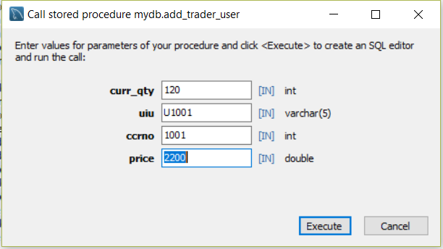



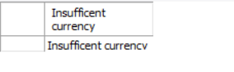

1. **TO REFLECT THE CHANGE IN PRICE OF CRYPTOCURRENCY.**

CREATE DEFINER=`root`@`localhost` PROCEDURE `tochangeprice`(in ccrno int(11),in new_price double)

BEGIN

declare datenow date;

declare timenow time;

declare tempcurprice double;

declare supplystamp int(11);

select current_date() into datenow;

select current_time() into timenow;

select circulating_supply into supplystamp from cryptocurrency where ccr_no=ccrno;

update cryptocurrency set cur_price=new_price where ccr_no=ccrno;

update cryptocurrency set pre_price=tempcurprice where ccr_no=ccrno;

insert into price_records (datepr,timepr,value_dollar,circulating_supply,crypto_pr_ccr_no) values(datenow,timenow,tempcurprice,supplystamp,ccrno);

END

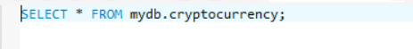

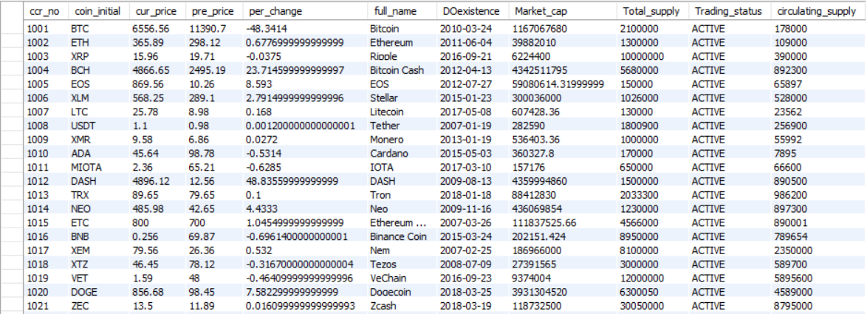

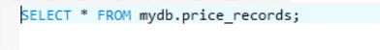

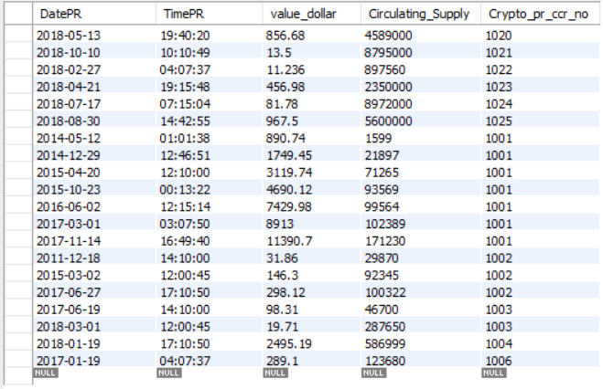

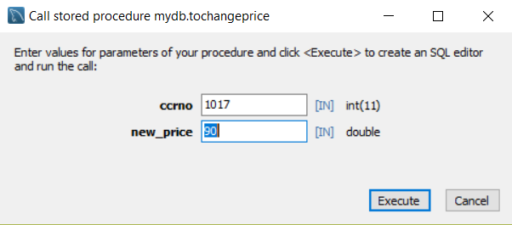

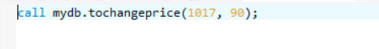

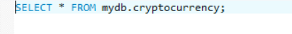

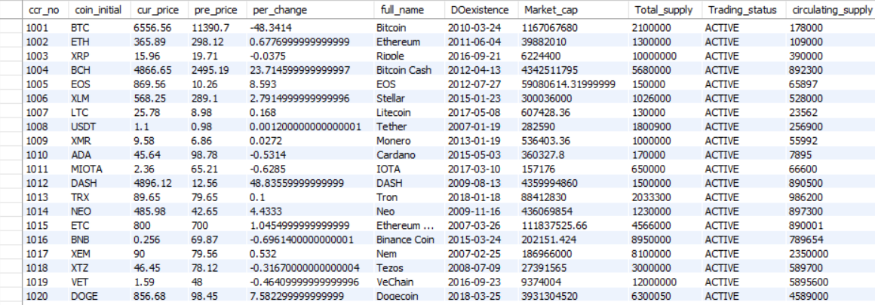

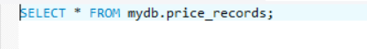

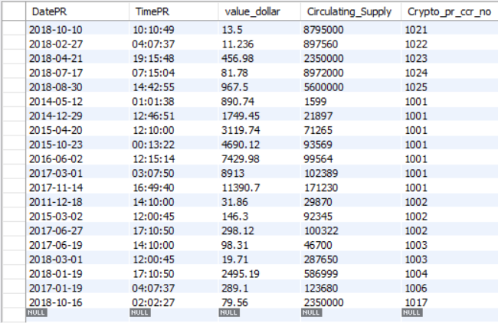

**2. FUNCTIONS**

**1. TO FIND THE TRADE VOLUME OF A CRYPTOCURRENCY ON A GIVEN DATE.**

CREATE DEFINER=`root`@`localhost` FUNCTION `trade_volume`(newccrno int(11),newdate date) RETURNS double DETERMINISTIC

BEGIN

declare qty int;

declare done int default 0;

declare val double;

declare total double default 0;

declare summ double default 0;

declare cc cursor for

select quantity,value_d from trade_record

where crypto_ccr_no=newccrno and t_date=newdate;

declare continue handler for not found set done=1;

open cc;

read_loop: loop

fetch cc into qty,val;

if done then

leave read_loop;

end if;

set total=(qty*val);

set summ=summ+total;

end loop;

-- select summ;

close cc;

RETURN summ;

END

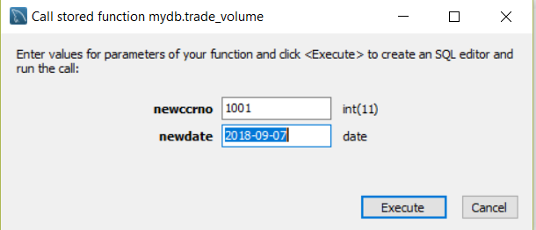



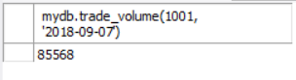

* 1. **VIEWS**
* **VIEW ON COMMON DATA FOR CRYPTOCURRENCY.**

CREATE

ALGORITHM = UNDEFINED

DEFINER = `root`@`localhost`

SQL SECURITY DEFINER

VIEW `commondetails` AS

SELECT

`cryptocurrency`.`coin_initial` AS `coin_initial`,

`cryptocurrency`.`full_name` AS `full_name`,

`cryptocurrency`.`cur_price` AS `cur_price`,

`cryptocurrency`.`per_change` AS `per_change`,

`cryptocurrency`.`Market_cap` AS `market_cap`

FROM

`cryptocurrency`

WHERE

(`cryptocurrency`.`Trading_status` = 'ACTIVE')



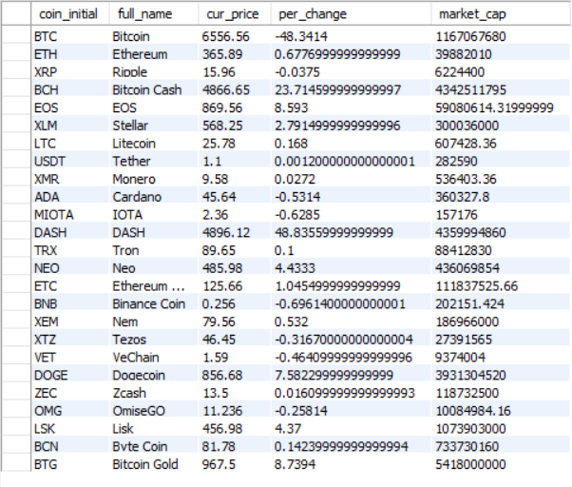

* **VIEW ON CRYPTOCURRENCY SALE.**

CREATE

ALGORITHM = UNDEFINED

DEFINER = `root`@`localhost`

SQL SECURITY DEFINER

VIEW `cryptosale` AS

SELECT

`tu`.`Cryptocurrency_ccr_no` AS `cryptocurrency_ccr_no`,

`tu`.`User_info_user_id` AS `user_info_user_id`,

`c`.`full_name` AS `full_name`,

`tu`.`Price_per_coin` AS `price_per_coin`,

`tu`.`Trade_Qty` AS `trade_qty`,

`c`.`cur_price` AS `cur_price`

FROM

(`trader_user` `tu`

JOIN `cryptocurrency` `c` ON ((`tu`.`Cryptocurrency_ccr_no` = `c`.`ccr_no`)))

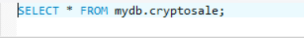

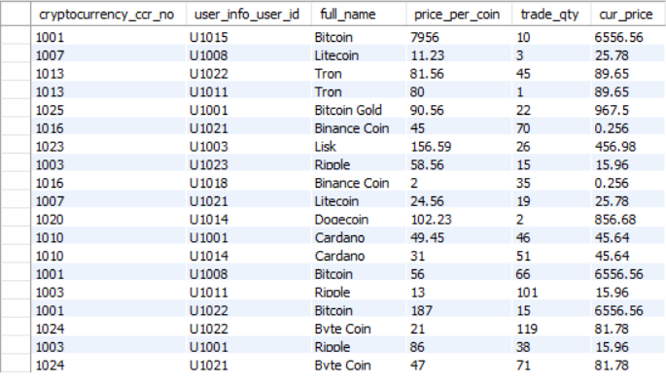

* 1. **TRIGGERS**

1. **TRIGGER OF USER_INFO.**

CREATE DEFINER=`root`@`localhost` TRIGGER `user_info_BEFORE_INSERT` BEFORE INSERT ON `user_info` FOR EACH ROW BEGIN

set new.age = timestampdiff(year,new.DOBu,curdate());

insert into tab_seq values(null);

set new.user_id=concat('U10',lpad(last_insert_id(),3,'0'));

END

1. **TRIGGER OF FOUNDER_ID.**

CREATE DEFINER=`root`@`localhost` TRIGGER `fIDincrement` BEFORE INSERT ON `founder` FOR EACH ROW BEGIN

insert into trade_seq values(null);

set new.f_id=concat('F1',lpad(last_insert_id(),3,'0'));

END

* 1. **CURSORS**
* **TO FIND THE NETWORTH OF GIVEN USER.**

CREATE DEFINER=`root`@`localhost` PROCEDURE `networth`(in useridnew varchar(7))

BEGIN

declare quantity int;

declare done int default 0;

declare cost double;

declare total double default 0;

declare c1 cursor for

select a.aqty,c.cur_price from assets a inner join cryptocurrency c on a.asset_ccr_no=c.ccr_no and a.asset_user_id=useridnew;

declare continue handler for not found set done=1;

open c1;

read_loop:loop

fetch c1 into quantity,cost;

if done then

leave read_loop;

end if;

set total=total+(quantity*cost);

end loop;

select total;

close c1;

END

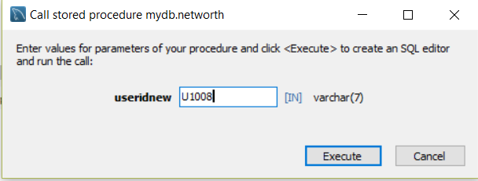

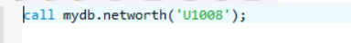

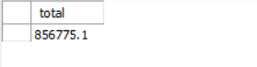

**6. FUTURE ENHANCEMENTS OF THE SYSTEM**

In order to assist users to decide which Cryptocurrency to hold and for how much time, a Trading Platform can be developed into a more advanced one with the use of ARTIFICIAL INTELLIGENCE.

This advanced Platform will predict the price of cryptocurrency on the basis of parameters such as the past fluctuations, market capitalization, circulating supply, period of the year etc.

This will make users aware of the ups and downs of the cryptocurrencies, and help them gain maximum profit

**7. BIBLIOGRAPHY**

For The Successful Working Of Our Project We Have Referred Many Sources For. The Code Snippets, Logics Tips & Tips From The Various Books As Well As Websites. Most I Searched For Requirement Possession On The Books . Many Of The Logics In My Project Are Used From The Book Which We Referred & The Concepts There In Book Which Indeed Provided A Platform To Achieve Such Reliable System Database.

**Reference books:**

* Data Base System Concepts

- Henry F.Korth&A.Silberschatz. 2nd Ed. McGraw-Hill 1991

* SQL, PL/SQL The programming language of Oracle

- Ivan Bayross, BPB Publications

**Reference Link:**

* http://en.wikipedia.org/wiki/Database
* www.w3schools.com/sql